**Using Gulp in ASP.NET MVC Core Projects**

**Lab Exercise**

Table of Contents

1 Introduction 3

2 Introducing Gulp 3

3 Running Default Tasks 5

4 Defining and Running a New Task 8

5 Defining and Running Tasks in a Series 9

6 IntelliSense 10

7 Development, Staging, and Production Environments 10

8 Switching Between Environments 11

9 Task and Module Details 11

10 Summary 12

# Introduction

In a typical modern web application, the build process might be

* Bundle and minify JavaScript and CSS files.
* Run tools to call the bundling and minification tasks before each build.
* Compile LESS or SASS files to CSS.
* Compile CoffeeScript or TypeScript files to JavaScript.

A task runner is a tool which automates these routine development tasks and more. Visual Studio provides built-in support for two popular JavaScript-based task runners: Gulp and Grunt.

# Introducing Gulp

Gulp is a JavaScript-based streaming build toolkit for client-side code. It is commonly used to stream client-side files through a series of processes when a specific event is triggered in a build environment. Some advantages of using Gulp include the automation of common development tasks, the simplification of repetitive tasks, and a decrease in overall development time. For instance, Gulp can be used to automate bundling and minification or the cleansing of a development environment before a new build.

A set of Gulp tasks is defined in gulpfile.js. The following JavaScript, includes Gulp modules and specifies file paths to be referenced within the forthcoming tasks:

/// <binding Clean='clean' />

"use strict";

**var** gulp **=** require("gulp"),

rimraf **=** require("rimraf"),

concat **=** require("gulp-concat"),

cssmin **=** require("gulp-cssmin"),

uglify **=** require("gulp-uglify");

**var** paths **=** {

webroot**:** "./wwwroot/"

};

paths.js **=** paths.webroot **+** "js/**/*.js";

paths.minJs **=** paths.webroot **+** "js/**/*.min.js";

paths.css **=** paths.webroot **+** "css/**/*.css";

paths.minCss **=** paths.webroot **+** "css/**/*.min.css";

paths.concatJsDest **=** paths.webroot **+** "js/site.min.js";

paths.concatCssDest **=** paths.webroot **+** "css/site.min.css";

The above code specifies which Node modules are required. The require function imports each module so that the dependent tasks can utilize their features. Each of the imported modules is assigned to a variable. The modules can be located either by name or path. In this example, the modules named gulp, rimraf, gulp-concat, gulp-cssmin, and gulp-uglify are retrieved by name. Additionally, a series of paths are created so that the locations of CSS and JavaScript files can be reused and referenced within the tasks. The following table provides descriptions of the modules included in gulpfile.js.

| **Module Name** | **Description** |
| --- | --- |
| gulp | The Gulp streaming build system. For more information, see gulp. |
| rimraf | A Node deletion module. For more information, see rimraf. |
| gulp-concat | A module that will concatenate files based on the operating system’s newline character. For more information, see gulp-concat. |
| gulp-cssmin | A module that will minify CSS files. For more information, see gulp-cssmin. |
| gulp-uglify | A module that minifies .js files using the UglifyJS toolkit. For more information, see gulp-uglify. |

Once the requisite modules are imported, the tasks can be specified. Here there are six tasks registered, represented by the following code:

gulp.task("clean:js", **function** (cb) {

rimraf(paths.concatJsDest, cb);

});

gulp.task("clean:css", **function** (cb) {

rimraf(paths.concatCssDest, cb);

});

gulp.task("clean", ["clean:js", "clean:css"]);

gulp.task("min:js", **function** () {

**return** gulp.src([paths.js, "!" **+** paths.minJs], { base**:** "." })

.pipe(concat(paths.concatJsDest))

.pipe(uglify())

.pipe(gulp.dest("."));

});

gulp.task("min:css", **function** () {

**return** gulp.src([paths.css, "!" **+** paths.minCss])

.pipe(concat(paths.concatCssDest))

.pipe(cssmin())

.pipe(gulp.dest("."));

});

gulp.task("min", ["min:js", "min:css"]);

The following table provides an explanation of the tasks specified in the code above:

| **Task Name** | **Description** |
| --- | --- |
| clean:js | A task that uses the rimraf Node deletion module to remove the minified version of the site.js file. |
| clean:css | A task that uses the rimraf Node deletion module to remove the minified version of the site.css file. |
| clean | A task that calls the clean:js task, followed by the clean:css task. |
| min:js | A task that minifies and concatenates all .js files within the js folder. The .min.js files are excluded. |
| min:css | A task that minifies and concatenates all .css files within the css folder. The .min.css files are excluded. |
| min | A task that calls the min:js task, followed by the min:css task. |

# Running Default Tasks

If you haven’t already created a new Web app, create a new ASP.NET Web Application project in Visual Studio.

First and Foremost

In your project.json, ensure that you have added dependency to Node.js as below - in the appropriate section

------------------

..........

"Microsoft.Extensions.Logging.Debug": "1.0.0",

"Microsoft.Extensions.Options.ConfigurationExtensions": "1.0.0",

"Microsoft.VisualStudio.Web.BrowserLink.Loader": "14.0.0",

"Node.js": "5.3.0"

},

1. Add a new JavaScript file to your Project and name it gulpfile.js, copy the following code.

/// <binding Clean='clean' />

"use strict";

**var** gulp **=** require("gulp"),

rimraf **=** require("rimraf"),

concat **=** require("gulp-concat"),

cssmin **=** require("gulp-cssmin"),

uglify **=** require("gulp-uglify");

**var** paths **=** {

webroot**:** "./wwwroot/"

};

paths.js **=** paths.webroot **+** "js/**/*.js";

paths.minJs **=** paths.webroot **+** "js/**/*.min.js";

paths.css **=** paths.webroot **+** "css/**/*.css";

paths.minCss **=** paths.webroot **+** "css/**/*.min.css";

paths.concatJsDest **=** paths.webroot **+** "js/site.min.js";

paths.concatCssDest **=** paths.webroot **+** "css/site.min.css";

gulp.task("clean:js", **function** (cb) {

rimraf(paths.concatJsDest, cb);

});

gulp.task("clean:css", **function** (cb) {

rimraf(paths.concatCssDest, cb);

});

gulp.task("clean", ["clean:js", "clean:css"]);

gulp.task("min:js", **function** () {

**return** gulp.src([paths.js, "!" **+** paths.minJs], { base**:** "." })

.pipe(concat(paths.concatJsDest))

.pipe(uglify())

.pipe(gulp.dest("."));

});

gulp.task("min:css", **function** () {

**return** gulp.src([paths.css, "!" **+** paths.minCss])

.pipe(concat(paths.concatCssDest))

.pipe(cssmin())

.pipe(gulp.dest("."));

});

gulp.task("min", ["min:js", "min:css"]);

1. Create new file  package.json file (add if not there) and add the following.

{

"version": "1.0.0",

"name": "asp.net",

"private": true,

"devDependencies": {

"gulp": "3.8.11",

"gulp-concat": "2.5.2",

"gulp-cssmin": "0.1.7",

"gulp-uglify": "1.2.0",

"rimraf": "2.2.8"

}

1. In **Solution Explorer**, right-click gulpfile.js, and select **Task Runner Explorer**.

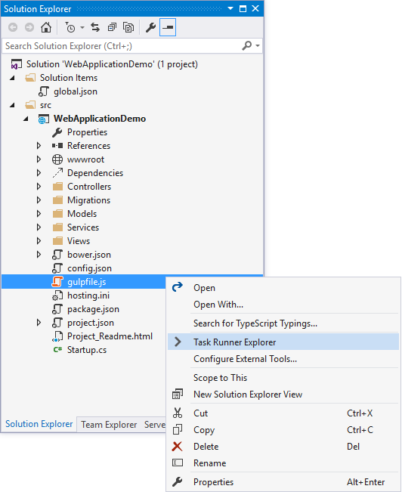

**Task Runner Explorer** shows the list of Gulp tasks. In the default ASP.NET Core Web Application template in Visual Studio, there are six tasks included from gulpfile.js.

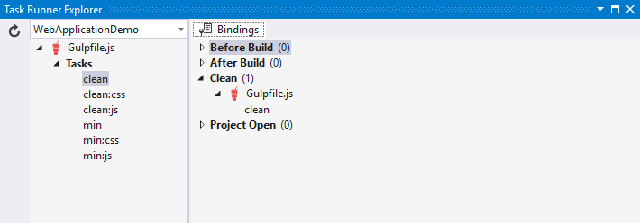

1. Underneath **Tasks** in **Task Runner Explorer**, right-click **clean**, and select **Run** from the pop-up menu.

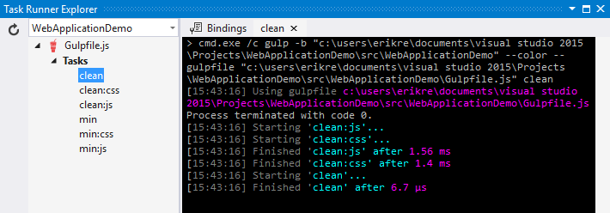

**Task Runner Explorer** will create a new tab named **clean** and execute the related clean task as it is defined in gulpfile.js.

1. Right-click the **clean** task, then select **Bindings** > **Before Build**.

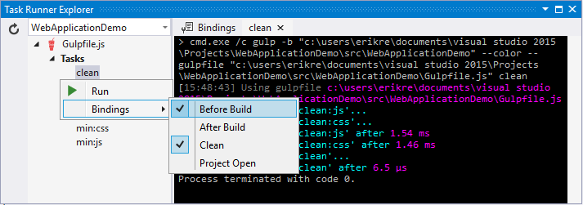

The **Before Build** binding option allows the clean task to run automatically before each build of the project.

It’s worth noting that the bindings you set up with **Task Runner Explorer** are **not** stored in theproject.json. Rather they are stored in the form of a comment at the top of your gulpfile.js. It is possible (as demonstrated in the default project templates) to have gulp tasks kicked off by thescripts section of your project.json. **Task Runner Explorer** is a way you can configure tasks to run using Visual Studio. If you are using a different editor (for example, Visual Studio Code) then using the project.json will probably be the most straightforward way to bring together the various stages (prebuild, build, etc.) and the running of gulp tasks.

**Note**

project.json stages are not triggered when building in Visual Studio by default. If you want to ensure that they are set this option in the Visual Studio project properties: Build tab -> Produce outputs on build. This will add a ProduceOutputsOnBuild element to your .xproj file which will cause Visual studio to trigger the project.json stages when building.

# Defining and Running a New Task

To define a new Gulp task, modify gulpfile.js.

1. Add the following JavaScript to the end of gulpfile.js:

gulp.task("first", **function** () {

console.log('first task! <-----');

});

This task is named first, and it simply displays a string.

1. Save gulpfile.js.
2. In **Solution Explorer**, right-click gulpfile.js, and select Task Runner Explorer.
3. In **Task Runner Explorer**, right-click **first**, and select **Run**.

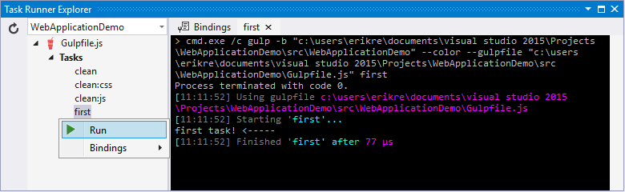

You’ll see that the output text is displayed. If you are interested in examples based on a common scenario, see Gulp Recipes.

# Defining and Running Tasks in a Series

When you run multiple tasks, the tasks run concurrently by default. However, if you need to run tasks in a specific order, you must specify when each task is complete, as well as which tasks depend on the completion of another task.

1. To define a series of tasks to run in order, replace the first task that you added above ingulpfile.js with the following:

gulp.task("series:first", **function** () {

console.log('first task! <-----');

});

gulp.task("series:second", ["series:first"], **function** () {

console.log('second task! <-----');

});

gulp.task("series", ["series:first", "series:second"], **function** () {});

You now have three tasks: series:first, series:second, and series. The series:second task includes a second parameter which specifies an array of tasks to be run and completed before theseries:second task will run. As specified in the code above, only the series:first task must be completed before the series:second task will run.

1. Save gulpfile.js.
2. In **Solution Explorer**, right-click gulpfile.js and select **Task Runner Explorer** if it isn’t already open.
3. In **Task Runner Explorer**, right-click **series** and select **Run**.

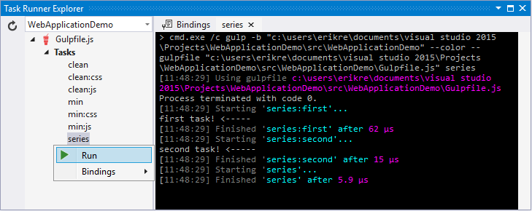

# IntelliSense

IntelliSense provides code completion, parameter descriptions, and other features to boost productivity and to decrease errors. Gulp tasks are written in JavaScript; therefore, IntelliSense can provide assistance while developing. As you work with JavaScript, IntelliSense lists the objects, functions, properties, and parameters that are available based on your current context. Select a coding option from the pop-up list provided by IntelliSense to complete the code.

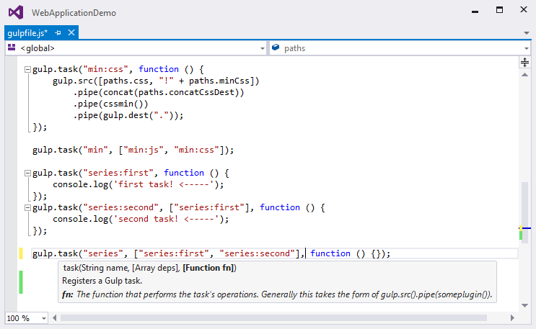

For more information about IntelliSense, see JavaScript IntelliSense.

# Development, Staging, and Production Environments

When Gulp is used to optimize client-side files for staging and production, the processed files are saved to a local staging and production location. The _Layout.cshtml file uses the **environment** tag helper to provide two different versions of CSS files. One version of CSS files is for development and the other version is optimized for both staging and production. In Visual Studio 2015, when you change the **Hosting:Environment** environment variable to Production, Visual Studio will build the Web app and link to the minimized CSS files. The following markup shows the **environment**tag helpers containing link tags to the Development CSS files and the minified Staging, ProductionCSS files.

<environment names**=**"Development">

<link rel**=**"stylesheet" href**=**"~/lib/bootstrap/dist/css/bootstrap.css" />

<link rel**=**"stylesheet" href**=**"~/css/site.css" />

</environment>

<environment names**=**"Staging,Production">

<link rel**=**"stylesheet" href**=**"https://ajax.aspnetcdn.com/ajax/bootstrap/3.3.5/css/bootstrap.min.css"

asp-fallback-href**=**"~/lib/bootstrap/dist/css/bootstrap.min.css"

asp-fallback-test-class**=**"sr-only" asp-fallback-test-property**=**"position" asp-fallback-test-value**=**"absolute" />

<link rel**=**"stylesheet" href**=**"~/css/site.min.css" asp-append-version**=**"true" />

</environment>

# Switching Between Environments

To switch between compiling for different environments, modify the **Hosting:Environment**environment variable’s value.

1. In **Task Runner Explorer**, verify that the **min** task has been set to run **Before Build**.
2. In **Solution Explorer**, right-click the project name and select **Properties**.

The property sheet for the Web app is displayed.

1. Click the **Debug** tab.
2. Set the value of the **Hosting:Environment** environment variable to Production.
3. Press **F5** to run the application in a browser.
4. In the browser window, right-click the page and select **View Source** to view the HTML for the page.

Notice that the stylesheet links point to the minified CSS files.

1. Close the browser to stop the Web app.
2. In Visual Studio, return to the property sheet for the Web app and change the**Hosting:Environment** environment variable back to Development.
3. Press **F5** to run the application in a browser again.
4. In the browser window, right-click the page and select **View Source** to see the HTML for the page.

Notice that the stylesheet links point to the unminified versions of the CSS files.

For more information related to environments in ASP.NET Core, see Working with Multiple Environments.

# Task and Module Details

A Gulp task is registered with a function name. You can specify dependencies if other tasks must run before the current task. Additional functions allow you to run and watch the Gulp tasks, as well as set the source (src) and destination (dest) of the files being modified. The following are the primary Gulp API functions:

| **Gulp Function** | **Syntax** | **Description** |
| --- | --- | --- |
| task | gulp.task(name[, deps], fn) { } | The task function creates a task. The name parameter defines the name of the task. The deps parameter contains an array of tasks to be completed before this task runs. The fn parameter represents a callback function which performs the operations of the task. |
| watch | gulp.watch(glob [, opts], tasks) { } | The watch function monitors files and runs tasks when a file change occurs. The glob parameter is a string or array that determines which files to watch. The opts parameter provides additional file watching options. |
| src | gulp.src(globs[, options]) { } | The src function provides files that match the glob value(s). The glob parameter is a string or array that determines which files to read. The options parameter provides additional file options. |
| dest | gulp.dest(path[, options]) { } | The dest function defines a location to which files can be written. The path parameter is a string or function that determines the destination folder. The options parameter is an object that specifies output folder options. |

For additional Gulp API reference information, see Gulp Docs API.

# Summary

Gulp is a JavaScript-based streaming build toolkit that can be used for bundling and minification. Visual Studio automatically installs Gulp along with a set of Gulp plugins. Gulp is maintained onGitHub. For additional information about Gulp, see the Gulp Documentation on GitHub.